Directions to the Chicopee Police Training Center
15 Court St Chicopee, MA 01020

From Points East or West:
- Take I-90 (Mass Turnpike) to Exit 49; Bear right at fork towards Rt33 Chicopee/Westover
- Turn right on Rt33 South
- Drive one mile and cross bridge at Chicopee Falls
- Stay in the right lane on bridge; on the other side, bear right following the sign towards Chicopee Center onto Church St
- Turn right onto Court St, then left into the parking lot

From Points North:
- Take I-91 South to Exit 11 (I-90 Mass Turnpike); follow signs to I-90 East Worcester/Boston
- Follow above directions From Points East or West

From Points South:
- Take I-91 North to Exit 6 (I-291 East to I-90 Boston)
- Continue on I-291 for five miles taking Exit 7 onto I-90 (Mass Turnpike) interchange; bear right on I-90 West Albany
- Follow above directions From Points East or West

*Above directions are the simplest; GPS directions MAY give you more direct/shorter directions

HOTEL LIST
Hotel Dist. to HQ Ave. Nightly Rate
- Hampton Inn Chicopee/Springfield 1.7 mi ~ $140
- Residence Inn Springfield/Chicopee 1.4 mi ~ $180
- Residence Inn West Springfield 4.5 mi ~ $140
- Hampton Inn West Springfield 4.2 mi ~ $150
- Sheraton Springfield 5.4 mi ~ $160
- Hampton Inn Springfield/Downtown 6.0 mi ~ $140
- Hilton Garden Inn Springfield 6.2 mi ~ $140

There are other hotels/motels in the area with similar or different price points. List provided is based on past user recommendation. Listed rates are recent without government or association discount codes.

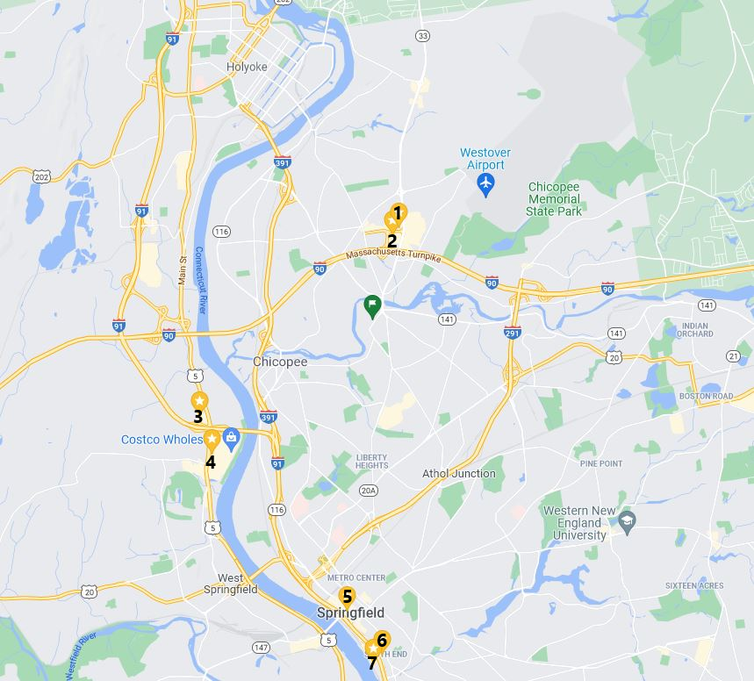
*Green Flag (centered) is CPD Training Center – 15 Court St Chicopee, MA 01020

